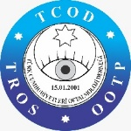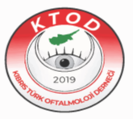
TROS & CTOS INTERNATIONAL OPHTHALMOLOGY CONGRESS KYRENIA
26-29 March 2026

Title of the Presentation :
Author(s): * Mark the presenter in bold letters

Institution(s) :

Correspondence: Email, telephone
TROS Membership Number of the Author(s):

Key Words
Abstract text: please refer to Abstract guidelines’ *

Bildiri Gönderimi:
Lütfen ekteki ‘Abstract Submission ’ formu, Özet Bildiri Yazım Kurallarına uygun şekilde doldurarak zelihayazar@gmail.com , gulizardemirok@hotmail.com ve umay.guvenc@gmail.com adreslerine tek mailde gönderebilirsiniz.

Abstract Submission:
Authors are kindly requested to complete the attached “Abstract Submission” form in accordance with the Abstract Preparation Guidelines and submit it via a single email to zelihayazar@gmail.com, gulizardemirok@hotmail.com, and umay.guvenc@gmail.com.

